**Title:** CS1026 Lab 1 (XOR Gate)

**Date:** 26/10/2017

**Aim:** To design an XOR using NAND Gates to implement the function F(a,b) = a’b + a b’.

**Logic Diagram:**

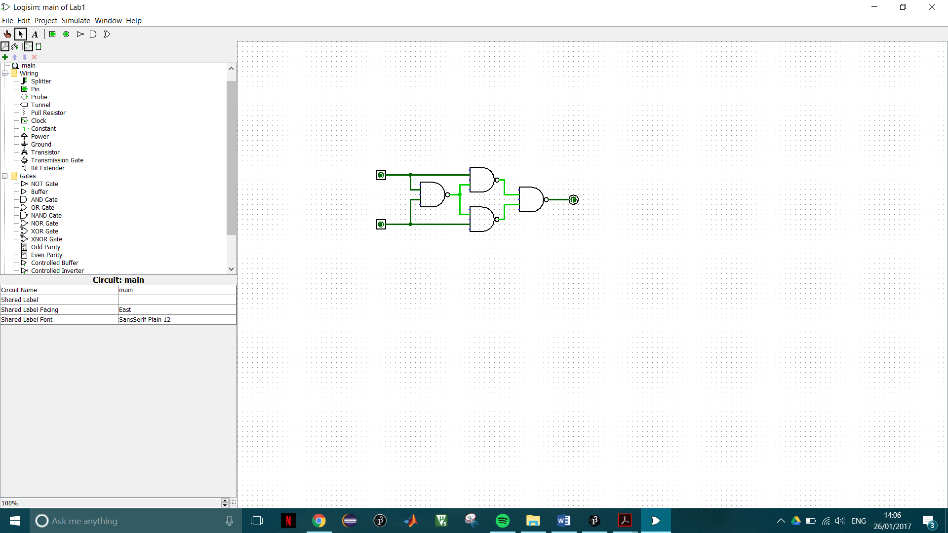

**Analysis:**

* I began by examining the truth table for an XOR gate with two inputs and found the variables needed to satisfy which are x’y+xy’
* Using Boolean algebra I expanded this function until I came upon a solution that contained parts which were in the form (ab)’
* I then designed a circuit to implement the Boolean algebra solution on the design software Logisim
* Following this I then tested the circuit using the input variables a and b to see if it was in fact an XOR Gate

**Boolean Algebra:**

**F = a’b + ab’**

= a’b +ab’ + aa’ + bb’

= (a+b)(a’+b’) *Simplifying*

=(a+b)(ab)’ *DeMorgans*

= a(ab)’ + b(ab)’

F’ = [a(ab)’ + b(ab)’]’ *Find F’*

= (a(ab)’)’ . (b(ab)’)’ *DeMorgans*

**F = [(a(ab)’)’ . (b(ab)’)’]’** *Invert to F*